SECTION 12 KEY SCENARIOS AND FINDINGS

12.1 Introduction To Scenarios and Findings
Several key scenarios were used to assess the achievement and maintenance of the Chesapeake water quality standards for dissolved oxygen, chlorophyll, and clarity (EPA, 2003a;EPA, 2003b). One key scenario was the 2010 Tributary Strategy Scenario, which encompassed the estimated 2010 management conditions , land use, and human and animal populations. Other key scenarios included an All Forest Scenario, which estimated the relative amount of anthropogenic loads in the watershed, and scenarios representing key Chesapeake Bay Program years of 1985, 2002, and 2010.
12.2 Difference Between Phase 5 Calibration and Scenario Operations
Hydrology calibration and simulation
Sediment and water quality calibration and simulation
12.3 Transport and Delivery Factors
Describe use and meaning of nutrient and sediment transport factors and delivery factors.
12.3.1 Transport Factors
Text
12.3.2 Delivery Factors
Have the delivery factors of nitrogen tabulated from the Base calibration and for a key scenario like the Tributary Strategy to see how the nitrogen delivery factors change with the changing loads. Put in table 12.3.2 here of the delivery factors & this table would need to be hot linked.

Phosphorus on the other hand, has an interesting twist. The loads of nitrogen are nonconservative and denitrification removes nitrogen from the system. Phosphorus on the other hand is completely conservative. It’s not removed from the system but moves through the watershed like a ping-pong ball swatted by the larger storm flows. So over a long time period the phosphorous will get to tidal waters sure as the mountains wash to the sea. The watershed yields of less than unity are mostly based on monitoring data and two things are wrong with this data. First the monitoring data doesn’t do very well with storm loads of phosphorus, and unless storm weighted monitoring is used, will underestimate storm and long-term phosphorus loads. Secondly the time frame isn’t long enough as a time frame of several decades would be needed to demonstrate a yield of unity.

The sediment delivery ratio we can calculate, either from the monitoring data or from the model in the Chesapeake, shows us that for some basins with 100 year storms and the like, the yield of phosphorus is well above 1! We can do this because the time frame of monitoring is greater than 20 years and flow weighted monitoring us used for these monitoring stations. Rather than using calculated yields for phosphorus, which can be greater or less than unity depending on the presence or absence of these large storms, we choose to use a constant delivery factor of 1.0. This is only applied in the “scenario mode” though when we’re attributing the delivered loads to the source in the watershed.
12.4 Land and River Segment Loads
Describe the use and meaning of loads from land and river segments.

12.4 Point Source Loads
Explain the use of the design flows for point sources in our scenarios and how that’s done so that the load may increase in scenarios with the concentration fixed by NPDES but design flow greater than existing flow. This may be justified due to the sunk costs of the upgrades to the design flow. The analysis for when population growth exceeds the design flow is uncertain, but our best estimates are that there would still be considerable excess capacity basin-wide with the design flows even in 2025 which is likely to be our maximum future projection of scenario loads

12.4 On-Site Wastewater Treatment System (OWTS) Loads
Explain the use of population and whatever “magic” Peter has done to project septic system loads.
12.5 Key Scenarios
Several key scenarios illustrate features of model behavior under high and low loadings. The highest loading is the historically high loads of 1985. Prior to 1985 the nutrient loads had steadily increased, particularly since the widespread use of fertilizers and hydrocarbon fuels after the mid-1940s. After 1985 the reductions encourage by State and Federal actions began to reduce nutrient loads from the 1985 zenith.
12.5.1 1985 High Historical Load Scenario
This scenario uses the estimated 1985 land uses, animal numbers, atmospheric deposition, and point source loads as described in Table 12.5.1. This scenario estimates the highest loads of nutrients and sediment to the Bay in recent time (using a constant 1991-2000 hydrology.
12.5.2 2002 Scenario
This scenario uses the estimated 2002 land uses, animal numbers, atmospheric deposition, and point source loads (Table 12.5.1). the 21002 year was chosen for simulation because it was the last year that had complete, unextrapolated land use data from the Agricultural Census.
12.5.3 2010 Tributary Strategy Scenario
This scenario estimates the nutrient and sediment loads of the jurisdictions’ 2003 Tributary Strategies throughout the Chesapeake Bay watershed using the Phase 5.1 Watershed and Chesapeake Bay Water Quality and Sediment Transport Models. This scenario included an accounting for all the Tributary Strategy BMPs on a 2010 land use, and the 2010 estimated permitted loads for all the significant and non-significant wastewater dischargers, as described in Table 1, that the watershed states have developed to achieve the states’ Bay dissolved oxygen and chlorophyll water quality standards. Any adjustments needed to the states’ Tributary Strategies to reflect changes in State laws or policies (e.g., permitting of significant wastewater discharge facilities) since agreement on the 2003 Allocations and development of the initial set of jurisdictional tributary strategies were also included in this scenario’s input decks. Atmospheric deposition inputs were from the CMAQ 12 km grid with an estimated 2010 deposition and included estimated State Implementation Plans to reach the 2010 Air Quality Standards.

Table 12.5.1. Point source load assumptions for the key scenarios of the Tributary Strategy, E3, 1985 No Action and the 2010 No-Action.
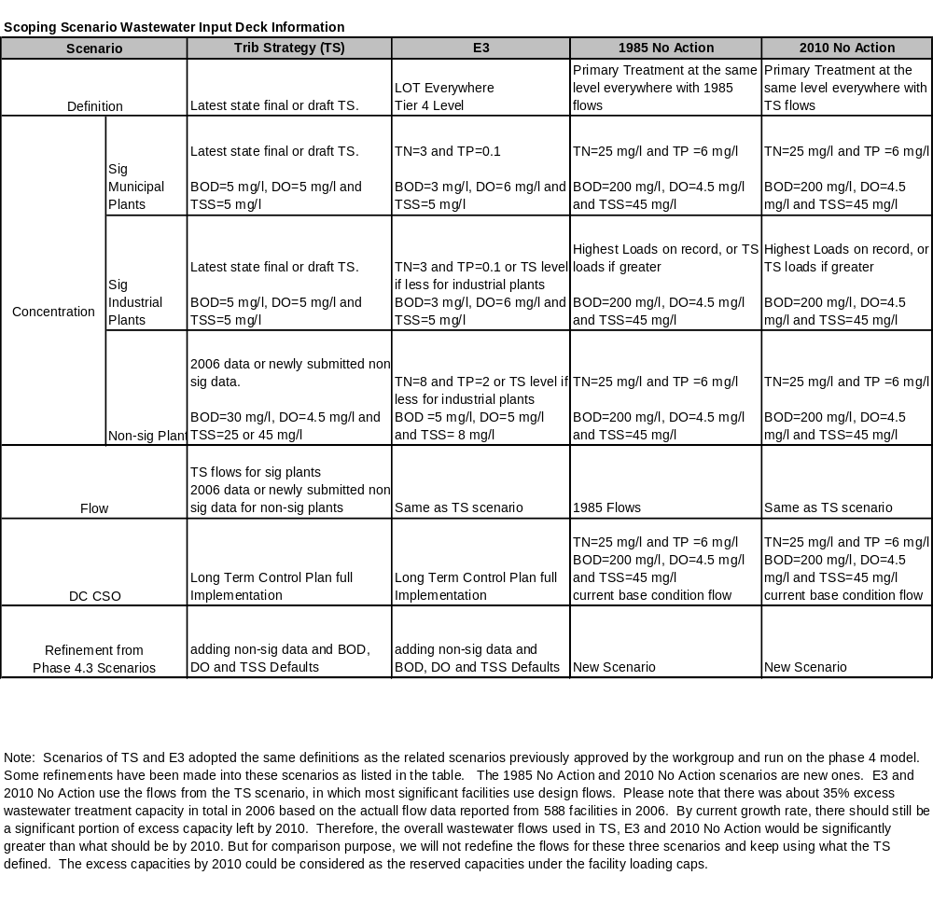
12.5.4 1985 No-Action Scenario
This scenario estimates nutrient and sediment loads under the conditions of no environmental point sources and nonpoint source controls using a 1985 land use and population. Major widespread management practices such as nutrient management and conservation tillage were eliminated in this scenario. Point source load assumptions were of primary treatment only with no phosphate detergent ban (Table 12.5.1). Atmospheric deposition loads were set to 1985 levels of emissions and controls.
12.5.5 2010 No-Action Scenario
This scenario estimates nutrient and sediment loads under the conditions of no environmental point sources and nonpoint source controls using a 2010 land use and population.. Major widespread management practices such as nutrient management and conservation tillage were eliminated in this scenario. Point source load assumptions were of primary treatment only with no phosphate detergent ban (Table 12.5.1). Atmospheric deposition loads were set to 1985 levels of emissions and controls.
12.5.6 Everyone, Everything, Everywhere (E3) Scenario
Here we examine one estimate of the application of management actions to the fullest possible extent. The E3Scenario is also the starting point of a UAA, if needed. To put this scenario together we used the same decision rules that we used for the previous E3 scenario run on the Phase 4.3 Chesapeake Bay watershed model back in the 2002 timeframe. Point source loads are as described in Table 12.5.1. For atmospheric deposition, we ran the 2020 LOT scenario run on the 12 km CMAQ grid. Table 1. Point source significant and non-significant wastewater discharges for the Tributary Strategy, E3, 1985 No-Action and 2010 No-Action.
12.5.7 All Forest with Clean Air Scenario
For this scenario, we use only the forests land use throughout the watershed and we assume the pristine atmospheric deposition is 1 lb/ac/year atmospheric deposition on average. This is consistent with literature values of estimated pristine atmospheric deposition. The emission sources are fires and lightning, which would be more evenly distributed geographically than the current atmospheric deposition. We assume that wet and dry deposition have the same ratio as the current ratio and calculate the wet and dry atmospheric load in each model segment with:
Dry deposition = current dry fraction * 1 lb/ac/year = .65 lb/ac/year
Wet concentration = current wet fraction * 1 lb/ac/year / weighted average rainfall
12.5.8 All Forest with Current Air Scenario
This scenario uses an all forest land use and current estimated atmospheric deposition loads for the 1991 – 2000 period.
12.6 Comparing Phase 5.2 and Phase 4.3 Scenarios

12.7 Climate Change Estimated Effect on Nutrient and Sediment Loads
During the last century, the Chesapeake Bay watershed, like much of the U.S., experienced warming temperatures, increases in precipitation, and increases in the average intensity of precipitation events. Projections of future climate suggest these trends are likely to continue, and in many cases intensify. Water resources and aquatic ecosystems are highly vulnerable to these changes with possible effects including increased occurrence of floods and droughts, water quality degradation, channel instability and habitat loss, and impacts on aquatic biota.

Water managers in the Chesapeake watershed face significant challenges associated with the impacts of landuse, increases in water demand, ecosystem degradation and other stressors. They recognize that climate change could impact their systems; however, it is rarely explicitly considered because of the lack of information about the scope, magnitude, and timing of potential effects. An improved understanding of climate change impacts through an extension of the Phase 5 Watershed Model capabilities enables water managers to better evaluate risk and make informed decisions about meeting supply needs, complying with water quality regulations, and protecting aquatic ecosystems over a range of time scales.

The assessment of climate change in the Chesapeake was supported by use of tools developed for EPA’s BASINS 4 system including the Climate Assessment Tool (CAT). Flows and associated nutrient and sediment loads were assessed in all river basins of the Chesapeake Bay with three key climate change scenarios reflecting the range of potential changes in temperature and precipitation in the year 2030. The three key scenarios came from a larger set of 42 climate change scenarios that were evaluated from 7 GCM models, 2 IPCC SRES storylines, and 3 assumptions about precipitation intensity in the largest events. Downscaling of GCM temperature and precipitation data sets were provided by Consortium for Atlantic Regional Assessment (CARA: http://www.cara.psu.edu/ ) Weather data reflecting each climate change scenario were created by modifying a 16 year period of historical data of precipitation and temperature from 1984 to 2000. Climate change estimates were combined with a 2030 estimated land use based on a sophisticated land use model containing socio-economic estimates of development throughout the watershed.

Key basins of the Chesapeake watershed are examined and differences among the basin responses to future climate change are noted through a comparison of a 2030 scenario without the estimated effects of climate change. The estimated tidal Bay response in dissolved oxygen, chlorophyll, and clarity can be further assessed through linkage with the Chesapeake Water Quality and Sediment Transport Model (WQSTM).
12.7.1. How the Three Key Climate Change Scenarios Were Selected
Three key climate change scenarios covering low, medium, and high outcomes effecting factors influencing Chesapeake water quality standards were assessed. The application of low, medium, and high climate change effects for a 2030 condition provides key support to the Chesapeake Bay Program’s assessment of the water quality standards of dissolved oxygen, chlorophyll, and water clarity and what’s needed to achieve and maintain these standards at a 2030 future condition of population growth, point source flows, and land use.
Factors effecting the water quality standards are nutrient and sediment loads. Nutrient loads of nitrogen and phosphorus are important for the dissolved oxygen and chlorophyll standards, and sediment influences the Bay’s clarity standard. The Bay has long residence times, which are on the order of about nine months for dissolved material entering head of the Bay during a average year. Inorganic and labile nutrients would have longer transit times due to biological uptake and cycling. As a result, the Bay is relatively insensitive to the seasonal loads for nutrients, i.e., equivalent winter or summer loads of nutrients are roughly equivalent in generating dissolved oxygen or chlorophyll standard violations as shown in model runs using the 2002 Chesapeake Water Quality Model (Cerco & Noel, 2004).

Nitrogen loads are largely determined by the magnitude of the annual flows, but phosphorus and sediment are influenced peak flows and scouring of phosphorus and sediment from land surfaces and within river systems. An approach to combine these elements is to weight the influence of the combined nitrogen and phosphorus loads using a ratio nitrogen to phosphorus that ‘s used in generalized algal stoichiometry. Algal cells can be approximately represented as having ten parts nitrogen and one part phosphorus by weight (the Redfield ratio). An endpoint of nutrient loads that has the same ten to one weighting of nitrogen to phosphorus loads would be an effective endpoint for nutrients.

Sediment is also more effectively delivered to the Bay in peak or storm flows which scour sediment from the land surface and from stream and river beds. The effect of sediment is primarily on water clarity which is a standard designed to protect and restore submerged aquatic grasses (SAV). As the clarity standard is only effective during the SAV growing season, the effects of sediment loads would be weighted toward the spring, summer and early fall, The key period of the clarity standard is in effect is from April to October.
12.7.2 The BASINS Climate Assessment Tool
EPA’s Better Assessment Science Integrating Point and Nonpoint Sources (BASINS) is a
multipurpose environmental analysis system designed for use by regional, state, and local
agencies performing watershed and water quality-based studies. This system makes it possible to quickly assess large amounts of data in a format that is easy to use and understand. BASINS integrates environmental data, analytical tools, and modeling programs to support development of cost-effective approaches to watershed management and environmental protection. The current release of BASINS, version 4.0, is the first to be primarily based on a non-proprietary, open-source GIS foundation. The BASINS modeling system thus offers a unique platform upon which to develop additional tools useful to stakeholders concerned with climate change.

The design and capabilities of a new Climate Assessment Tool released with BASINS 4.0 facilitates the assessment of the influence of climate variability and change on a range of hydrologic and water quality endpoints. As used here, an endpoint is any hydrologic or water quality characteristic that can be calculated using output from the watershed models in BASINS. Examples include mean annual streamflow, annual water yield, a100-year flood event, a Q7-10, mean annual nutrient concentration, annual nutrient or sediment load, and maximum daily contaminant concentration. The Climate Assessment Tool also facilitates the assessment of adaptation strategies (e.g., BMPs) for increasing the resilience of different endpoints to climate variability and change.

Specific capabilities of Climate Assessment Tool include the ability to modify historical climate, generate synthetic weather time series, and conduct systematic sensitivity analyses for specific hydrologic and water quality end-points using the BASINS models. For example, users can manipulate climate variables to change long term mean, variability, monthly or seasonal characteristics, and the occurrence of individual “design” events. These changes in climatic parameters are then converted to modified meteorological time series, either through manipulation of historical observations or simulation using an embedded weather generator. Meteorological time series can be exported or used to drive BASINS hydrologic models, including HSPF.

In addition, the Climate Assessment Tool provides a capability to operate in an iterative mode to conduct systematic sensitivity analyses for specific hydrologic end-points. In this capacity, the tool iteratively manipulates the meteorological inputs, runs the hydrologic model, and manages output. The result is a profile of hydrologic responses to changes in two-dimensional combinations of climatic variables such as temperature and precipitation. This information will help water managers and other stakeholders understand the sensitivity of specific endpoints to prospective changes in climate. An understanding of sensitivity is a necessary foundation for conducting watershed-scale vulnerability analyses.
12.7.3 Initial Climate Change Findings
In our Chesapeake watershed, 2030 estimates of temperature are for increases of about 1.5 degrees centigrade with a high degree of certainty. Estimated precipitation increase among the seven global climate models used are about 2%, especially at higher rainfall events, and this is estimated with a moderate degree of certainty. How temperature and precipitation changes effect flow and associated nutrient and sediment loads in the watershed hangs in a hydrologic balance between precipitation and evapotranspiration. Temperature increases tend to increase evapotranspiration in watersheds and this can offset increases in precipitation.

This seems to be the case in the Chesapeake watershed. Current estimates of the medians of the nine different scenarios run have an annual average flow, nitrogen, and phosphorus load decrease of -6.0%, -1.6%, and -2.1% respectively. Because sediment loads increase with higher rainfall events the median of the nine scenario estimates for sediment is for an increase of 4.9%. This work will continue to be refined over the next several years as improved global climate models and downscaling techniques become available.

We know that climate is changing and this has significant implications for our long-term Chesapeake Bay Program goals. Planning for long-term Bay restoration may involve the consideration of new questions:
• What are the potential impacts of climate change on water quality and living resources?
• How will our tributary strategies and other management actions perform under changing climatic conditions?
• What are the implications for water resources, such as water supply and flood control measures?

We can use the Chesapeake Bay integrated models of the watershed, estuary, and living resources with climate change tools to examine broader water resource issues and develop sensitivity analyses to understand the vulnerability of Bay program goals to climate changes.
12.8 Effects of Atmospheric Deposition of Acidity and Mercury
This section to be competed when the Hg module of the CMAQ Model is completed and will cover the mercury and ph atmospheric deposition inputs to the watershed as a data library for pH and mercury assessments and TMDLs

REFERENCES
Albek, M., Ogutveren, U.B., and Albek, E., 2004, Hydrological modeling of SeydiSuyu watershed (Turkey) with HSPF: Journal of Hydrology, v. 285, p. 260-271.

Cerco, C.F., and Noel, M.R., 2004, The 2002 Chesapeake Bay Eutrophication Model: U.S. EPA Chesapeake Bay Program Office.

Cosby, B.A., Norton, S.A., and Kahl, J.S., in press, Using a paired watershed manipulation experiment to evaluate a catchment scale biogeochemical model: Journal of Hydrology.

Cronin, T.M., 2000, Effects of Climate Variability and Human Activities on Chesapeake Bay and the Implications for Ecosystem Restoration: USGS FS-116-00.

Cronin, T.M., Dwyer, G.S., Kamiya, T., Schwede, S., and D.A.Willard, 2002, Medieval warm period, little ice age, and the 20th century temperature variability from Chesapeake Bay: Global and Palnitary Change, v. 748.

Cronin, T.M., Thunell, R., Dwyer, G.S., Saenger, C., Mann, M.E., Vann, C., and 2nd, R.R.S., 2005, Multiproxy evidence of Holocene climate variability from estuarine sediments, eastern North America: Paleoceanography, v. 20, no. PA4006, p. 1-21.

Cronin, T.M., and Walker, H.A., 2006, Restoring coastal ecosystems and abrupt climate change: An editorial essay: Climate Research.

DeCandis, A.J., and Najjar, R., 2006, Suspended sediment in Chesapeake Bay and its potential response to climate-induced changes in streamflow: submitted to Estuaries and Coasts July 3, 2006.

Division, C.B.R.a.M., and Program, M.D.P.P.a.R., 1995, Acid deposition in Maryland: Summary of 1993 research and monitoring results and evaluation of status and trends.: Chesapeake Bay Research and Monitoring Division, Tidewater Administration, Department of Natural Resources CBRM-AD-94-7.

Driscoll, C.T., 2007, Effects of Atmospheric Deposition of Acidity and Mercury on Freshwater and Other Sensitive Natural Resources in the Eastern U.S.: Testimony to the House Subcommittee on Water Resources and Environment.

Ellis, H., 1995, Maryland critical loads study: analysis of emissions reduction strategies, Volume II: Maryland Department of Natural Resources, Chesapeake Bay Research and Monitoring CBRM-AD-95-9.

Ellis, J.H., 1989, Acid rain control strategies from multiple long-range transport models, in Atmospheric Deposition Symposium - International Association of Hydrological Sciences, Baltimore, MD, IAHS, p. 37-44.

ES&T 1996. Acid Deposition may stunt forest growth, leach calcium, Hubbard Brook researchers report: Environmental Science and Technology, v. 30, no. 6, p. 239A-240A.

Fisher, A., Abler, D., Barron, E., Bord, R., Crane], R., Dewalle, D., Knight, C.G., Najjar, R., Nizeyimana, E., O'Conner, R., Rose, A., Shortle, J., and Yarnal, B., 2000, Preparing for Climate Change: Mid-Atlantic Overview: Penn State U.

Freemantle, M., 1995, The acid test for Europe: As sulfur emissions decrease in Europe, nitrogen oxides and ammonia attract increasing attention in the fight to control acidic deposition.: Chemical and Engineering News, no. May 1, 1995, p. 10-17.

Gibson, J.R., and Najjar, R.G., 2000, The response of the Chesapeake Bay salinity to climate-induced changes in streamflow: Limnology and Oceanography, v. 45, no. 8, p. 1764-1772.

Hawkins, D.G., and Svenson, E., 1997, Benchmarking Air Emissions of Electric Utility Generators in the Eastern United States: Natural Resource Defense Council.

Janicki, A., Wade, D., Wilson, H., Heimbuch, D., Sverdrup, H., and Warfvinge, P., 1995, Maryland critical loads study: Critical loads assessment for Maryland streams, Volume 1: Maryland Department of Natural Resources, Chesapeake Bay Research and Monitoring Division CBRM-AD-95-9.

Kahl, J.S., and Norton, S.A., 1993, Experimental inducement of nitrogen saturation at the watershed scale: Environmental Science and Technology, v. 27, no. 3, p. 565-568.

Maryland Commission on Climate Change, 2008, Climate Change Action Plan: Maryland Commission on Climate Change.

Milly, P.C.D., Betancourt, J., Falkenmark, M., Hirsch, R.M., Kundzewicz, Z.W., Lettenmaier, D.P., and Stouffer, R.J., 2008, Climate Change: Stationarity Is Dead: Whither Water Management? Science, v. 319, no. 5863, p. 573 - 574.

NAPAP, 1998, NAPAP Biennial Report to Congress: An integrated Assessment: National Acid Precipitation Assessment Program.

Najjar, R.G., 1999, The water balance of the Susquehanna River Basin and its response to climate change: Journal of Hydrology, v. 219, p. 7-19.

Najjar, R.G., Walker, H.A., Anderson, P.J., Barron, E.J., Bord, R.J., Gibson, J.R., Kennedy, V.S., Knight, C.G., Megonigal, J.P., O'Connor, R.E., Polsky, C.D., Psuty, N.P., Richards, B.A., Sorenson, L.G., Steele, E.M., and Swanson, R.S., 2000, The potential impacts of climate change on the mid-Atlantic coastal region: Climate Research, v. 14, p. 219-233.

Neff, R., Chang, H., Knight, C.G., Najjar, R.G., Yarnal, B., and Walker, H.A., 2000, Impact of climate variation and change on Mid-Atlantic Region hydrology and water resources: Climate Research, v. 14, p. 207-218.

Nikolaidis, N.P., Schnoor, J.L., and Georgakakos, K.P., 1989, Modeling of long-term lake alkalinity responses to acid deposition: Journal of the Water Pollution Control Federation, v. 61, no. 2, p. 188-199.

Norton, S.A., J. S. Kahl, I. J. Fernandez, L. E. Rustad, J. P. Scofield, T. A. Haines, 1994, Response of the West Bear Brook Watershed, Maine, USA, to the addition of (NH4)2SO4: 3-year results: Forest Ecology ad Management, v. 68, p. 61-73.

Norton, S.A., Kahl, J.S., and Scofield, J.P., 1995, Randomized intervention analysis of the response of the West Bear Brook watershed, Maine to chemical manipulation: Water, Air and Soil Pollution, v. 79, p. 131-146.

Regens, J.L., 1993, Acid Deposition, in Uman, M.F., ed., Keeping Pace with CScience and Engineering: Case Studies in Environmental Regulation: Washington, D.C., National Academy Press, p. 165-188.

Roberts, L., 1991, Learning from an acid rain program: Science, v. 251, p. 1302-1305.

Saenger, C., Cronin, T., Thunell, R., and Vann, C., 2006, Modeling river discharge and precipitation from estuarine salinity in the northern Chesapeake Bay: Application to Holocene paleoclimate: Holocene, v. 16, no. 4, p. 1-11.

Scientsts, U.o.C., 2006, Climate Change in the U.S. Northeast: Union of Concerned Scientists Publications.

Tebaldi, C., Hahoe, K., Arblaster, J.M., and Meehl, G.A., 2006, Going to extremes: An intercomparison of model simulated historical and future changes in extreme events: Climate Change, v. 79, p. 185-211.

U.S. EPA, 2003a. Technical Support Document for identification of Chesapeake Bay Designated Uses and Attainability. U.S. EPA Chesapeake Bay Program Office Annapolis, MD http://www.chesapeakebay.net/uaasupport.htm

U.S. EPA, 2003b. Ambient Water Quality Criteria for Dissolved Oxygen, Water Clarity and Chlorophyll a for the Chesapeake Bay and Its Tidal Tributaries. U.S. EPA Chesapeake Bay Program Office Annapolis, MD http://www.chesapeakebay.net/baycriteria.htm

Willard, D.A., Cronin, T.M., and Verardo, S., 2003, Late-holocene climate and ecosystem history from Chesapeake Bay sediment cores, USA: Holocene, v. 13, no. 2, p. 201-214.

Cite as:
U.S. EPA, 2009. Chesapeake Bay Phase 5 Community Watershed Model In preparation EPA XXX-X-XX-008 Chesapeake Bay Program Office, Annapolis MD. January 2009.

Revised July 27, 2009

